**JIRA - TABLEAU**

Project created in Jira for Test Environment Infrastructure

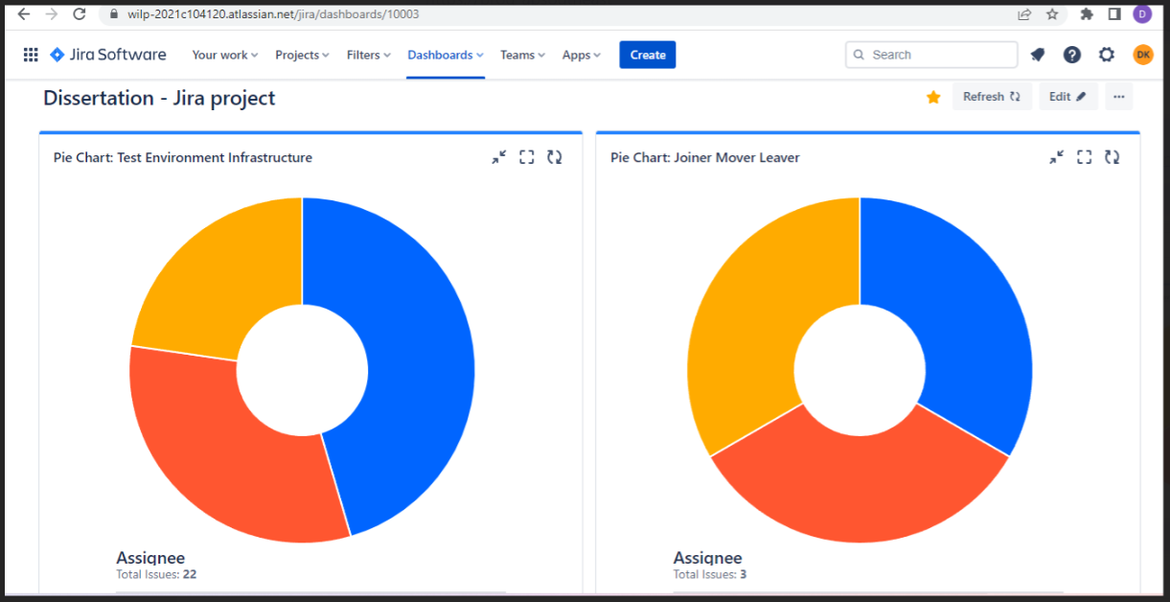

Bulk Import in Jira:

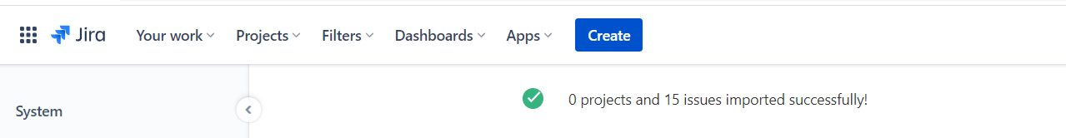

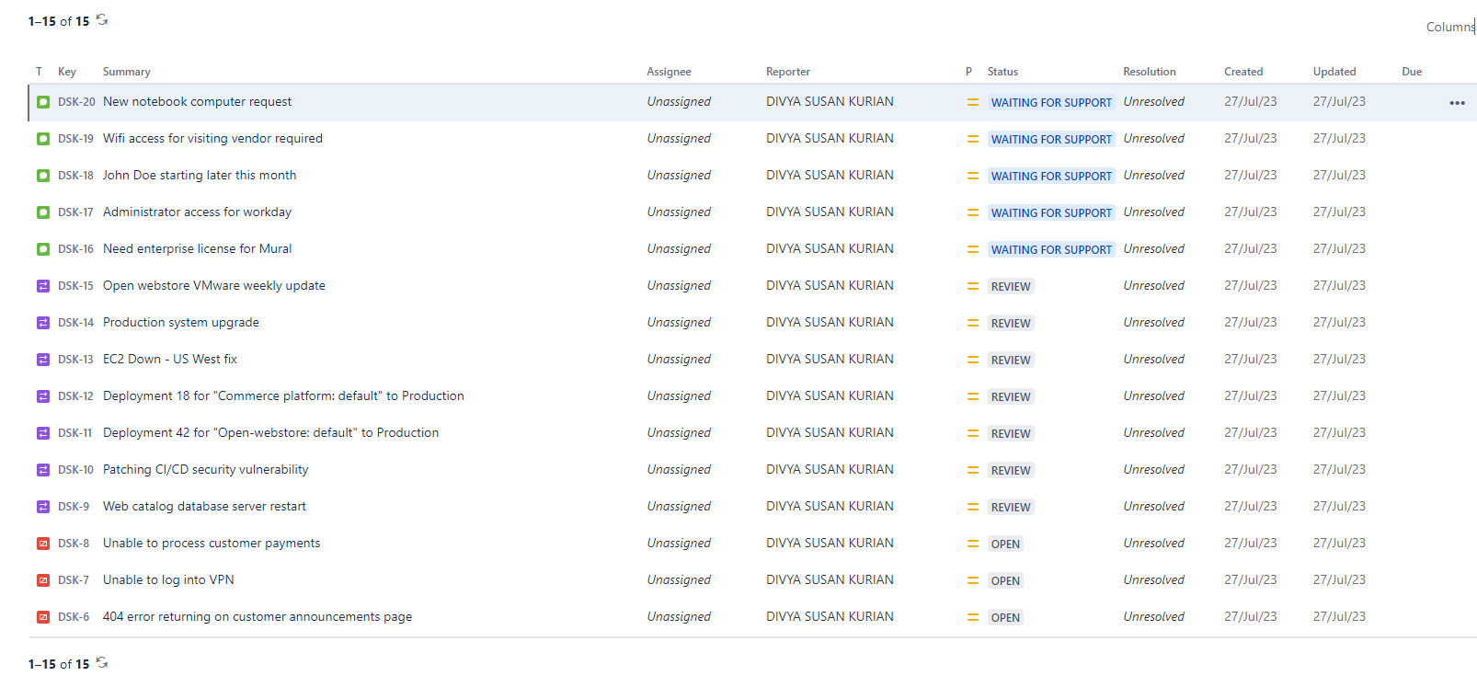

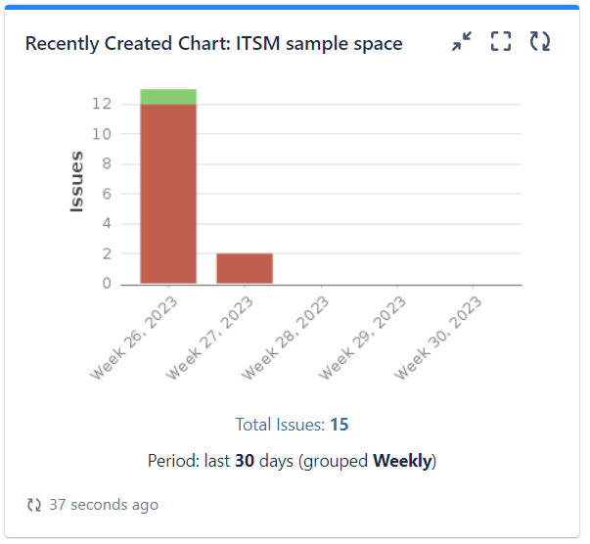

Mapping fields in Jira:

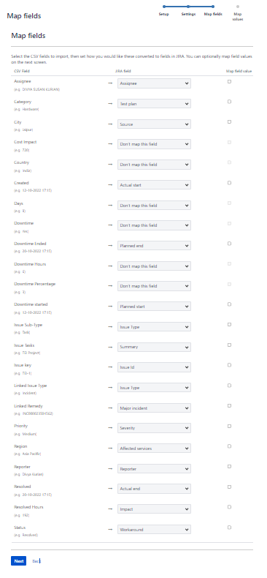

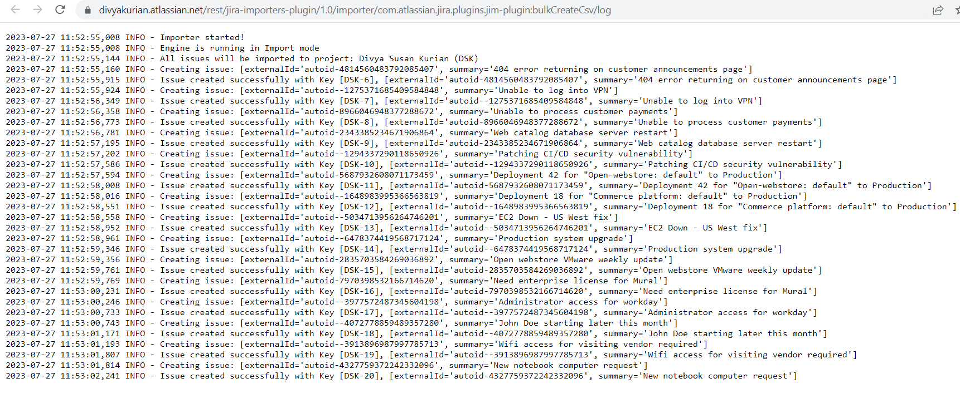

To Visualize Jira Data in Tableau

Using Tableau connector for Jira:

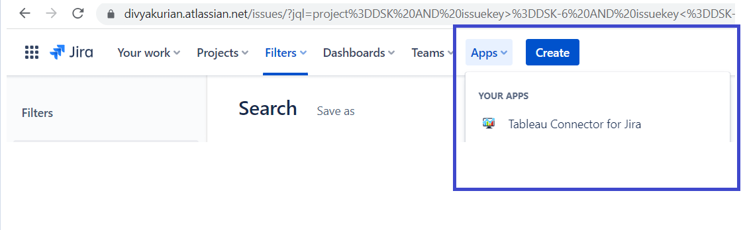

API Token created: <https://id.atlassian.com/manage-profile/security/api-tokens>

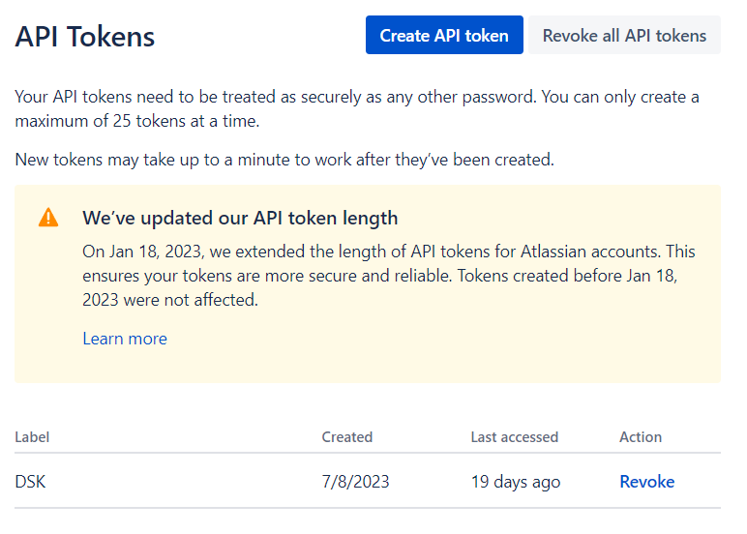

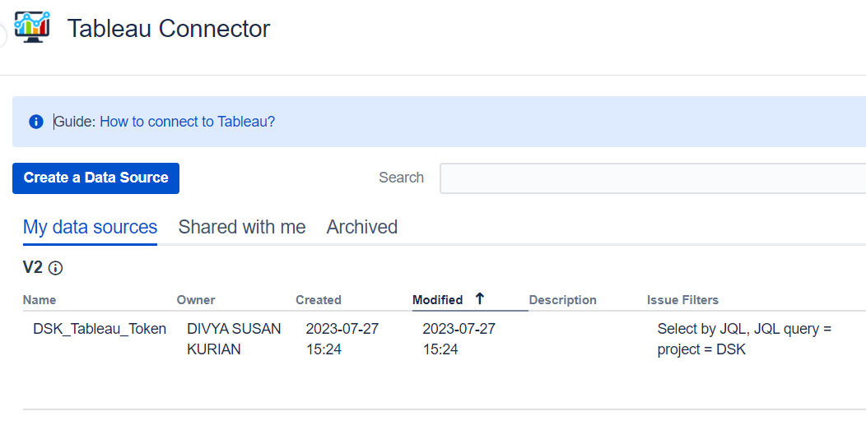

Connector saved successfully

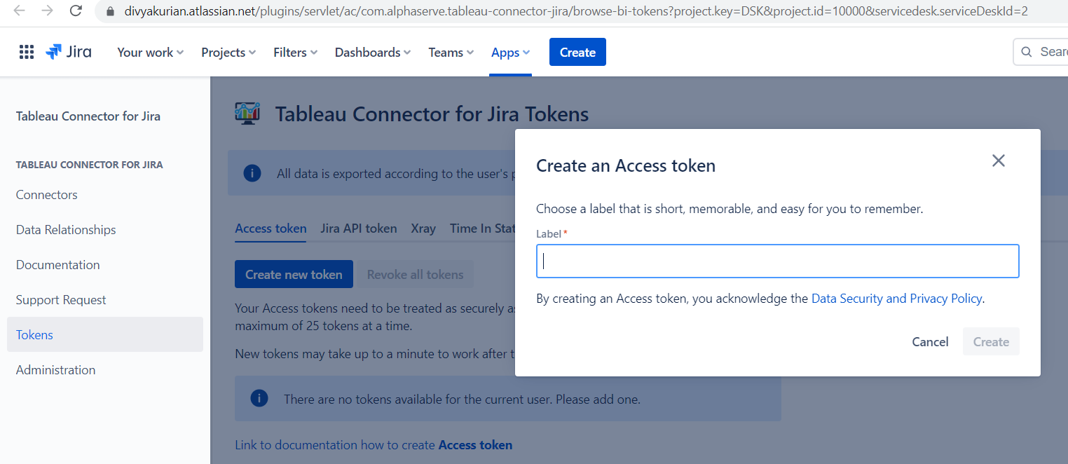 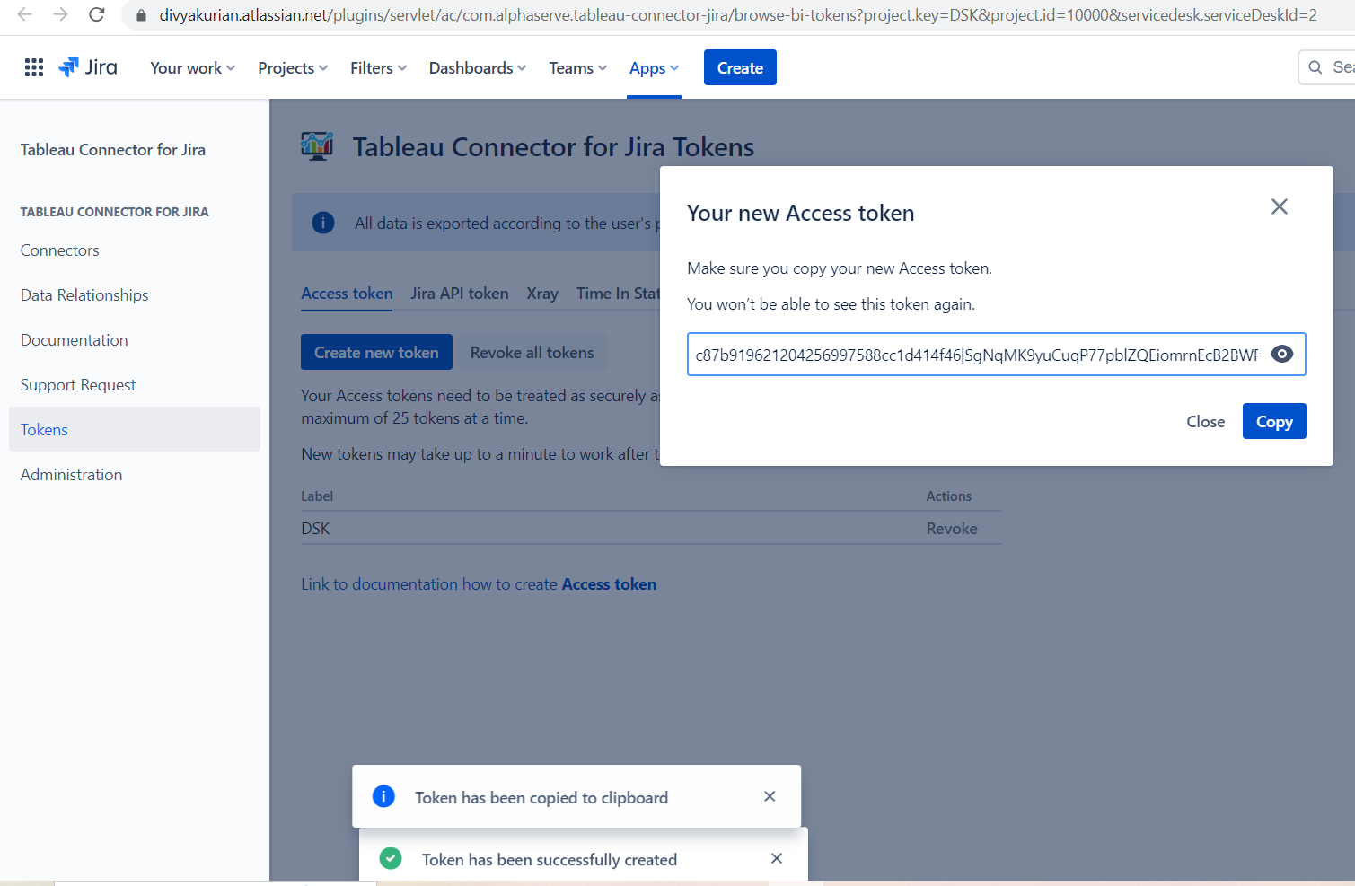

Creating Tableau Token:

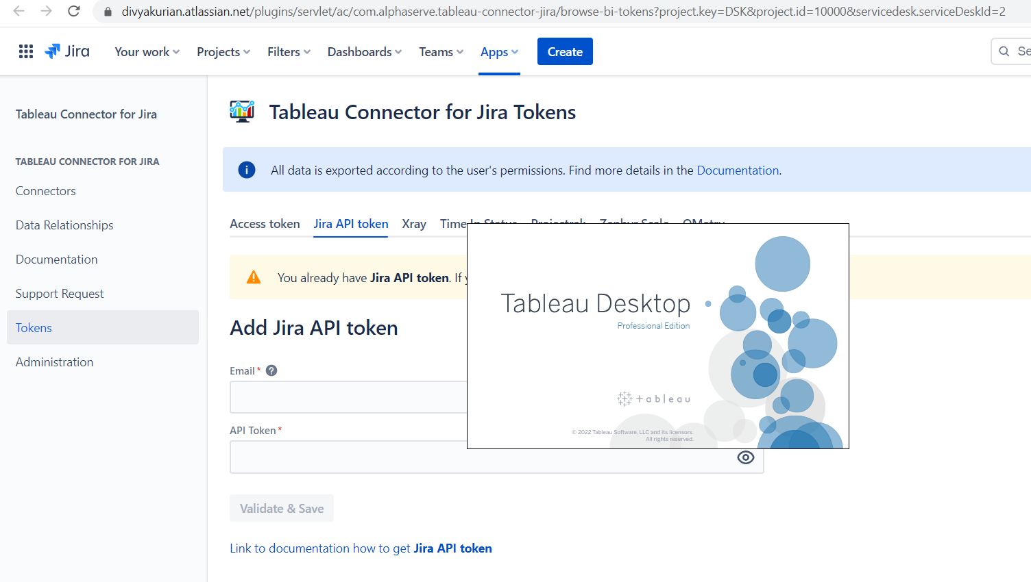

Download and install Tableau Desktop version:

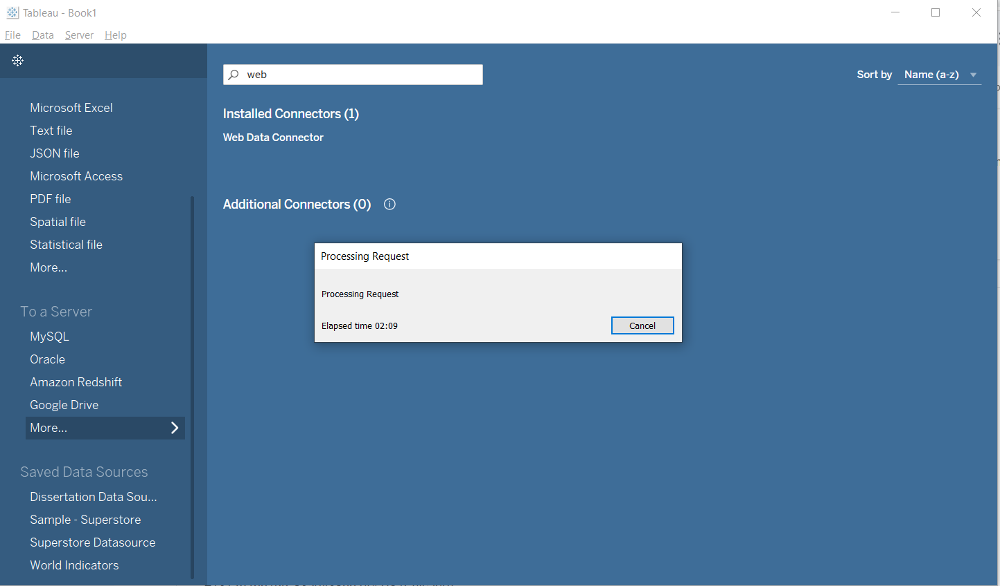

Jira Data source via Web Data Connector successful:

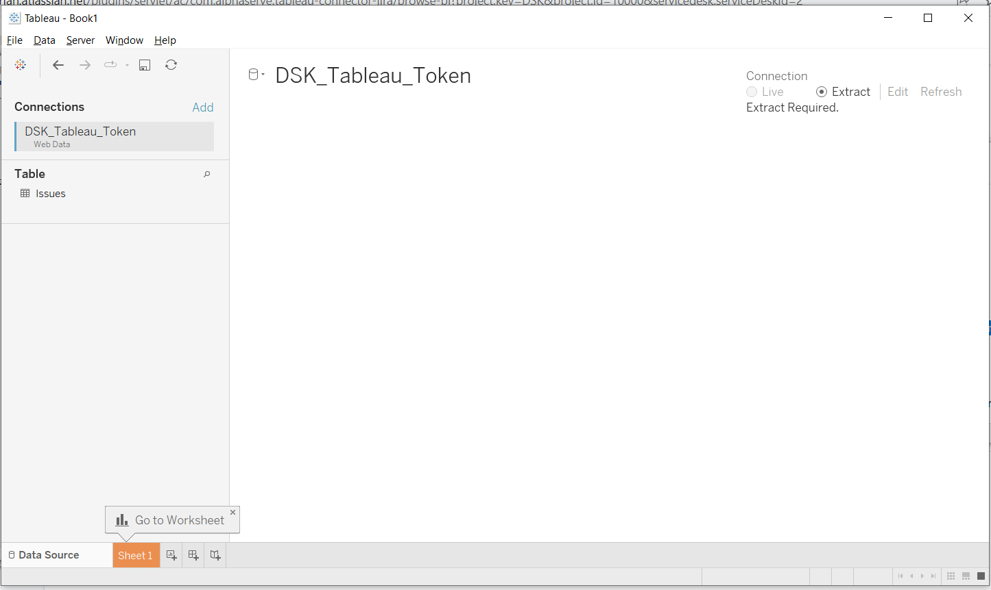

Jira Tableau connection established for the Viz:

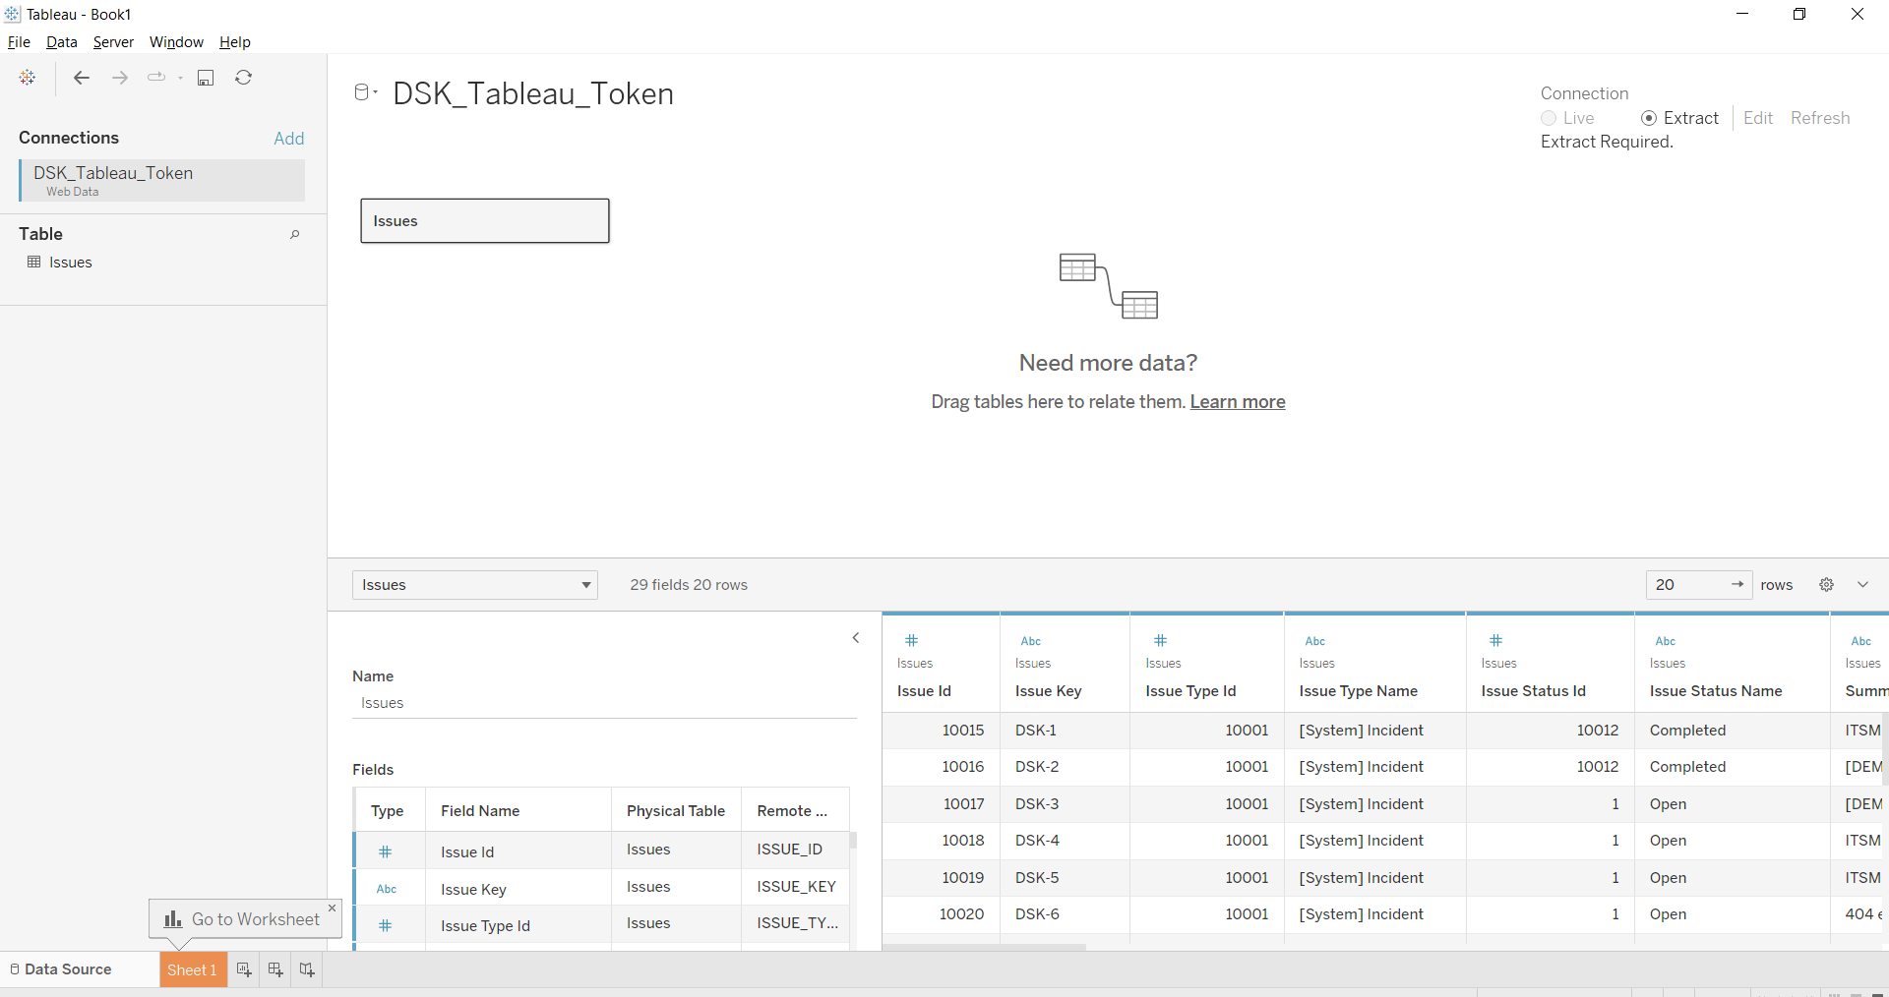

Workbook creation:

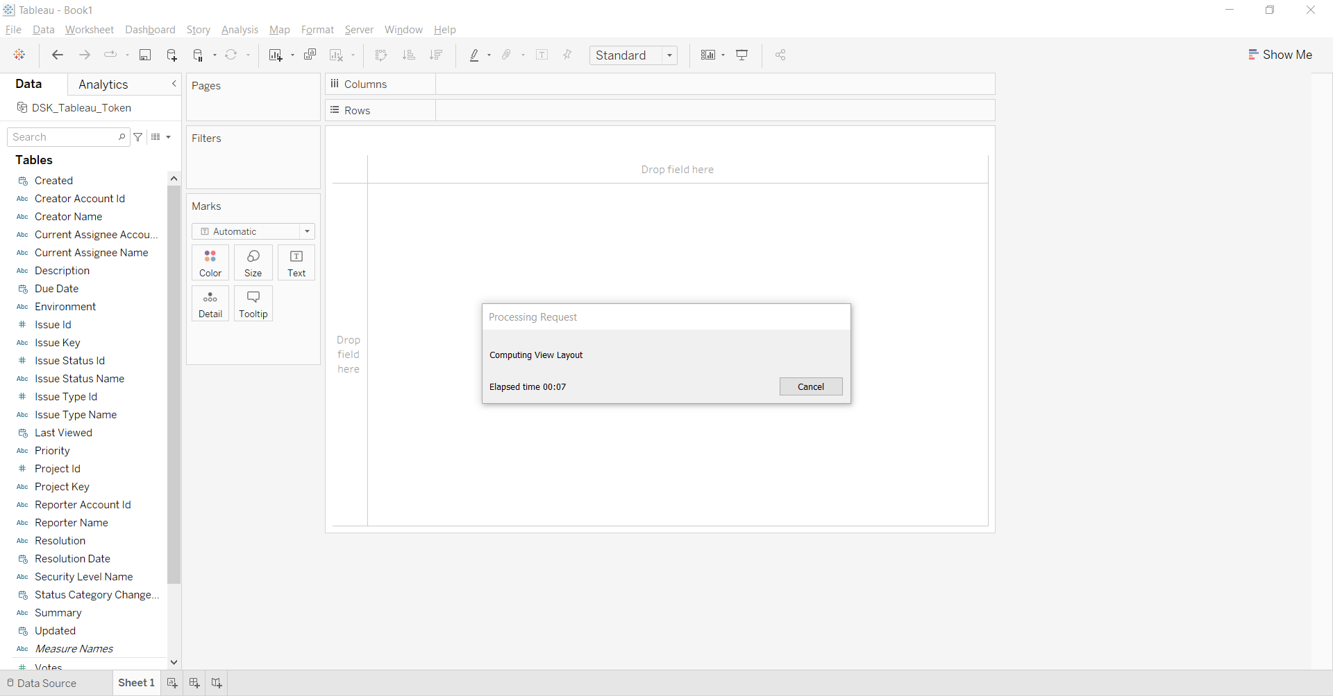

Tableau Worksheets and Dashboard Creation from Jira data:

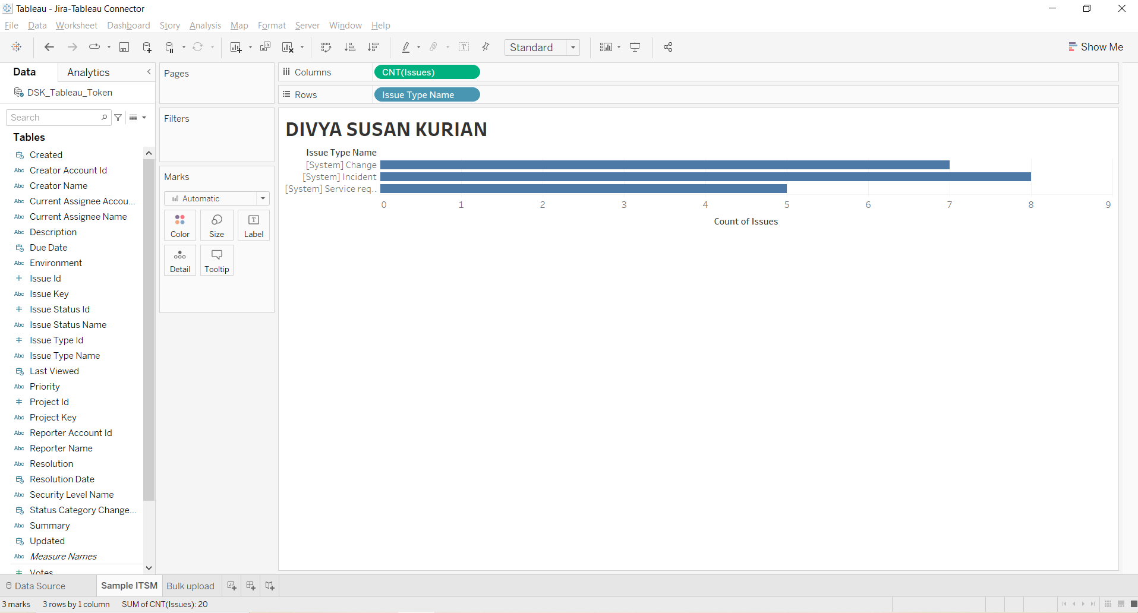

Filtered Jira data made available in Tableau:

